**Extra Practice Solutions:**

We really hope these are useful. As always let us know if you have any questions!

**Hello Program:**



**Hello Program v2:**

**Mario:**

* **Using a For Loop**



* **Using a While Loop**



**Iterate through a list under 150**

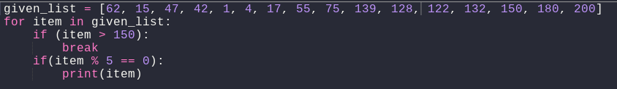

**Pattern**

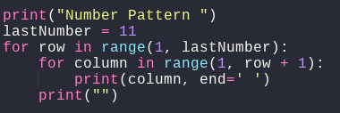

**Prime numbers problem:**

